**Background**

This project deals with popularity of online news. The internet age gives us both the need and opportunity to analyze factors that determine the number of shares a news article gets on the social media and predict the shares based on those factors for new news articles.

The data for this project is provided comes from the popular news sharing site [Mashable.com](http://mashable.com). Mashable presents news articles from various new and media outlets on many different topics. It even gives the number of shares on its news articles to indicate the popularity of the article. The goal that Mashable proposes for this data set is to predict whether the number of shares will be greater than 1400 or less than that number.

In this project I will explore why Mashable proposes this goal as a binary classification problem, and why it draws a boundary on the number 1400. I will also explore the feasibility of a more granular classification, which would more realistically reflect the share categories that Mashable news article actually fall into.

The data set provided by Mashable was taken from UCI machine learning laboratory. For more information on the data, please check this [link.](https://archive.ics.uci.edu/ml/datasets/Online+News+Popularity)

1. **Data Description**

The data set obtained from UCI Machine learning laboratory contains 39,797 records with 59 quantified features related to the particular news articles. In addition, there is one column for the link to the news article itself, and one for the dependent variable, i.e. the number of shares the news article gets.

The data set is described below:

|  |  |
| --- | --- |
| 0. url | URL of the article |
| 1. timedelta | Days between the article publication and the dataset acquisition |
| 2. n_tokens_title | Number of words in the title |
| 3. n_tokens_content | Number of words in the content |
| 4. n_unique_tokens | Rate of unique words in the content |
| 5. n_non_stop_words | Rate of non-stop words in the content |
| 6. n_non_stop_unique_tokens | Rate of unique non-stop words in the content |
| 7. num_hrefs | Number of links |
| 8. num_self_hrefs | Number of links to other articles published by Mashable |
| 9. num_imgs | Number of images |
| 10. num_videos | Number of videos |
| 11. average_token_length | Average length of the words in the content |
| 12. num_keywords | Number of keywords in the metadata |
| 13. data_channel_is_lifestyle | Is data channel 'Lifestyle'? |
| 14. data_channel_is_entertainment | Is data channel 'Entertainment'? |
| 15. data_channel_is_bus | Is data channel 'Business'? |
| 16. data_channel_is_socmed | Is data channel 'Social Media'? |
| 17. data_channel_is_tech | Is data channel 'Tech'? |
| 18. data_channel_is_world | Is data channel 'World'? |
| 19. kw_min_min | Worst keyword (min. shares) |
| 20. kw_max_min | Worst keyword (max. shares) |
| 21. kw_avg_min | Worst keyword (avg. shares) |
| 22. kw_min_max | Best keyword (min. shares) |
| 23. kw_max_max | Best keyword (max. shares) |
| 24. kw_avg_max | Best keyword (avg. shares) |
| 25. kw_min_avg | Avg. keyword (min. shares) |
| 26. kw_max_avg | Avg. keyword (max. shares) |
| 27. kw_avg_avg | Avg. keyword (avg. shares) |
| 28. self_reference_min_shares | Min. shares of referenced articles in Mashable |
| 29. self_reference_max_shares | Max. shares of referenced articles in Mashable |
| 30. self_reference_avg_sharess | Avg. shares of referenced articles in Mashable |
| 31. weekday_is_monday | Was the article published on a Monday? |
| 32. weekday_is_tuesday | Was the article published on a Tuesday? |
| 33. weekday_is_wednesday | Was the article published on a Wednesday? |
| 34. weekday_is_thursday | Was the article published on a Thursday? |
| 35. weekday_is_friday | Was the article published on a Friday? |
| 36. weekday_is_saturday | Was the article published on a Saturday? |
| 37. weekday_is_sunday | Was the article published on a Sunday? |
| 38. is_weekend | Was the article published on the weekend? |
| 39. LDA_00 | Closeness to LDA topic 0 |
| 40. LDA_01 | Closeness to LDA topic 1 |
| 41. LDA_02 | Closeness to LDA topic 2 |
| 42. LDA_03 | Closeness to LDA topic 3 |
| 43. LDA_04 | Closeness to LDA topic 4 |
| 44. global_subjectivity | Text subjectivity |
| 45. global_sentiment_polarity | Text sentiment polarity |
| 46. global_rate_positive_words | Rate of positive words in the content |
| 47. global_rate_negative_words | Rate of negative words in the content |
| 48. rate_positive_words | Rate of positive words among non-neutral tokens |
| 49. rate_negative_words | Rate of negative words among non-neutral tokens |
| 50. avg_positive_polarity | Avg. polarity of positive words |
| 51. min_positive_polarity | Min. polarity of positive words |
| 52. max_positive_polarity | Max. polarity of positive words |
| 53. avg_negative_polarity | Avg. polarity of negative words |
| 54. min_negative_polarity | Min. polarity of negative words |
| 55. max_negative_polarity | Max. polarity of negative words |
| 56. title_subjectivity | Title subjectivity |
| 57. title_sentiment_polarity | Title polarity |
| 58. abs_title_subjectivity | Absolute subjectivity level |
| 59. abs_title_sentiment_polarity | Absolute polarity level |
| 60. shares | Number of shares (target) |

**2. Feature Selection**

We need to select only the significant features of the model to reduce complexity and multicollinearity in the models. Principal Component Analysis (PCA) or Multi Factor Analysis (MFA) did not seem particularly suitable as feature selection techniques as my variable set contains a mixture of binary factors and continuous variables. Given the constraints, I took a more manual approach to feature selection. I used the rcorr() function to generate the correlation matrix along with the significance levels of each correlation. I flattened this matrix to get all the unique variable pairs and the correlations between them in rows. I started with studying only a subset of the variable pairs, which had absolute correlations greater than 10% with significance levels of greater than 95% (P-value < 0.05). From each of these variable pairs, I select the variable that has a greater correlation with the dependent variable (no. of shares).

The analysis described above does not yield clean solutions. This is because the above selection process has to deal with contests between pairs of variables that are not mutually exclusive. To give an example, *avg_positive_polarity* is a choice variable between many comparisons, but between avg_positive_polarity and *abs_title_sentiment_polarity*, *abs_title_sentiment_polarity* gets chosen. So between *avg_positive_polarity* and *abs_title_sentiment_polarity*, which one should get chosen?

To resolve this problem I devised a strategy that I have described schematically on the following page. We start with first rejecting any winning variable that has less than 1% correlation with the dependent variable. I call a particular variable a ‘winning’ variable here, if it’s the chosen one within a pair. As described above, a winning variable, say variable **A**, might be the looser in another contest with variable **B**. We want to know, with justifiable reasons, whether we should still select variable A and reject B, or select the winning variable B and reject the previous winner A, or select both.

Given both have greater than 1% correlation with the dependent variable, say Y, we check whether A had greater number of wins than B. We also check which among the two has a greater correlation with **Y**. If for these two tests, there’s a clear winner then we take that variable. If not, we check whether there’s a significant correlation between these two variables themselves. If so, we select the one with greater number of wins and reject the one with higher correlation with the dependent variable. The rationale behind this is thus:

1. If two variables have high correlation between themselves, they will likely have comparable correlation with dependent variable. Choosing both will introduce multicollinearity and complexity into the model
2. We choose the variable with higher number of wins because, given 1, we get to simplify the model without suffering from a significant loss of variance in the model.

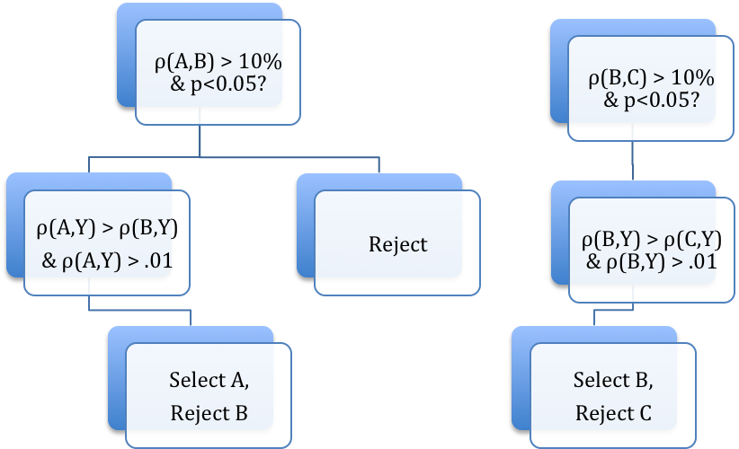

Yes

Yes

Yes

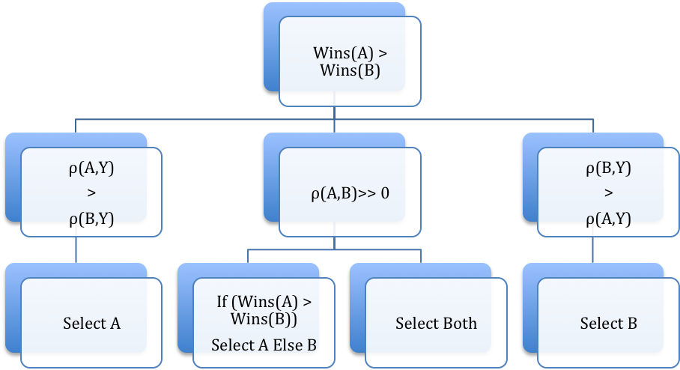

No =>

B preferred

No =>

A preferred

Yes

No

The last scenario is that there is no clear winner between A and B, and nor do they have a significant correlation between themselves. In this case we choose both. The contest between *avg_positive_polarity* and *abs_title_sentiment_polarity* fall into this exact category as described below.

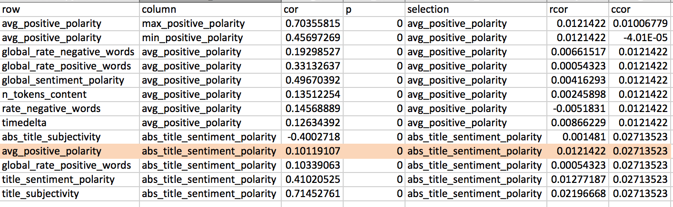

According to the scheme defined above, we observe that between avg_positive_polarity and abs_title_sentiment_polarity, avg_positive_polarity has the double the number of wins but abs_title_sentiment_polarity has double the correlation with number of shares. So there’s no clear choice. We then see whether correlation between avg_positive_polarity and abs_title_sentiment_polarity is significant. It is only 10%, our lower limit to even consider correlations between variables. Hence, we choose both and continue our analysis.

In such an analysis scheme, one of the two variables may get eliminated in another round of analysis. Following this scheme, I was able to reduce the significant features to 21 out of 60. On running these parameters in linear models, I eliminated another 3, which were not significant, leaving the set of selected features down to 18.

The following features made the final cut:

|  |  |
| --- | --- |
| 1 | num_hrefs |
| 2 | num_imgs |
| 3 | num_videos |
| 4 | average_token_length |
| 5 | data_channel_is_entertainment |
| 6 | data_channel_is_bus |
| 7 | kw_avg_min |
| 8 | kw_avg_max |
| 9 | kw_avg_avg |
| 10 | self_reference_avg_sharess |
| 11 | is_weekend |
| 12 | LDA_02 |
| 13 | LDA_03 |
| 14 | LDA_04 |
| 15 | global_subjectivity |
| 16 | avg_positive_polarity |
| 17 | title_subjectivity |
| 18 | title_sentiment_polarity |

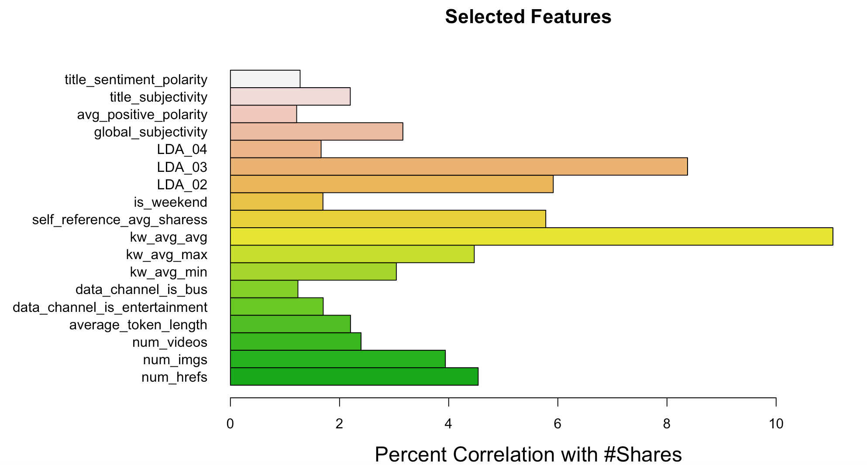

**3. Data Preparation**

**3.1 Capping**

Once the significant features are obtained, I removed the outliers by capping the data below 5% quantile to the 5% quantile value, and data above 95% quantile to the 95% quantile value. I did this for each of the columns except the first one which contains the actual news link.

**3.2 Scaling**

I centered and scaled all the continuous variables to bring all these variables on the same scale and make model coefficients intuitive and interpretable. The following variables were scaled:

1. shares

2. self_reference_min_shares

3. self_reference_avg_sharess

4. self_reference_max_shares

5. kw_avg_min

6. kw_avg_max

7. kw_avg_avg

A new variable “scaledy” is introduced above, which is nothing but scaled number of shares. Since number of shares is the dependent variable, we want to preserve the original variable for further use and keep it separate from it’s scaled version.

**3.3 Classification**

I intended to study this problem through both regression and classification. On an analysis of deciles of the number of shares, we find that 5th decile corresponds to exactly 1400 shares. It is now clear that original problem wants us to be able to discriminate between that two halves of it’s observed number of shares.

> quantile(onp$shares, probs = c(0.1, 0.2, 0.3, 0.4, 0.5, 0.6, 0.7, 0.8, 0.9, 1))

10% 20% 30% 40% 50% 60% 70% 80% 90% 100%

708.0 870.6 1000.0 1200.0 1400.0 1800.0 2300.0 3400.0 6200.0 10800.0

Hence I introduced two new variables for two-way classification. One is a binary classification between shares less than or equal to 1400 and greater than 1400. I do another 30-30-20-20 classification based on the above quantiles. Hence the 4-class classification is between shares up to a 1000, greater than 1000 and less than or equal to 1800, greater than 1800 and less than or equal to 3400, and greater than 3400. I present the distribution of data in the two classes as below:

> table(onp$classes)

1 2 3 4

12424 12020 7392 7808

> table(onp$classes2)

0 1

20082 19562

**3.4 Factoring**

To be able to tell my regression or classification models that the above two variables are indeed classes, I converted them to factors. Moreover, there are three dependent binary variables among the one that we chose that need to be factorized:

1. data_channel_is_bus

2. data_channel_is_entertainment

3. is_weekend

**3.5 Splitting**

I split the data into training and test sets on a 70%-30% data split.

**4. Models and Results**

**4.1 Linear Regression**

I started with a linear regression model, using the selected features. I used *scaledy* as the dependent variable. The R-squared from this model was a low 0.09.

> summary(model1.lr)

Call:

lm(formula = scaledy ~ average_token_length + avg_positive_polarity +

factor(data_channel_is_bus) + factor(data_channel_is_entertainment) +

global_subjectivity + factor(is_weekend) + kw_avg_avg + kw_avg_max +

kw_avg_min + LDA_02 + LDA_03 + LDA_04 + num_hrefs + num_imgs +

num_videos + self_reference_avg_sharess + title_sentiment_polarity +

title_subjectivity, data = TrainONP)

Residuals:

Min 1Q Median 3Q Max

-1.7604 -0.5126 -0.2803 0.0913 3.6871

Coefficients:

Estimate Std. Error t value Pr(>|t|)

(Intercept) 0.5785775 0.0956935 6.046 1.50e-09 ***

average_token_length -0.1253167 0.0196303 -6.384 1.75e-10 ***

avg_positive_polarity -0.3010560 0.0705611 -4.267 1.99e-05 ***

factor(data_channel_is_bus)1 -0.1122887 0.0187793 -5.979 2.26e-09 ***

factor(data_channel_is_entertainment)1 -0.2475756 0.0156570 -15.812 < 2e-16 ***

global_subjectivity 0.3510964 0.0676835 5.187 2.14e-07 ***

factor(is_weekend)1 0.1754585 0.0142610 12.303 < 2e-16 ***

kw_avg_avg 0.2024007 0.0073263 27.627 < 2e-16 ***

kw_avg_max -0.0649528 0.0072084 -9.011 < 2e-16 ***

kw_avg_min 0.0120977 0.0058217 2.078 0.037713 *

LDA_02 -0.2846464 0.0272197 -10.457 < 2e-16 ***

LDA_03 -0.0658378 0.0254020 -2.592 0.009550 **

LDA_04 -0.0876990 0.0253116 -3.465 0.000531 ***

num_hrefs 0.0045111 0.0007031 6.416 1.42e-10 ***

num_imgs 0.0043067 0.0009602 4.485 7.30e-06 ***

num_videos 0.0156842 0.0036810 4.261 2.04e-05 ***

self_reference_avg_sharess 0.1136776 0.0050017 22.728 < 2e-16 ***

title_sentiment_polarity 0.0738561 0.0247527 2.984 0.002849 **

title_subjectivity 0.0408377 0.0158298 2.580 0.009889 **

---

Signif. codes: 0 ‘***’ 0.001 ‘**’ 0.01 ‘*’ 0.05 ‘.’ 0.1 ‘ ’ 1

Residual standard error: 0.9495 on 39625 degrees of freedom

Multiple R-squared: 0.09894, Adjusted R-squared: 0.09853

F-statistic: 241.7 on 18 and 39625 DF, p-value: < 2.2e-16

Moreover, we can also observe from the correlogram of the residuals that theirs is no correlation present between the residuals, and hence the residuals are truly independent and unbiased.

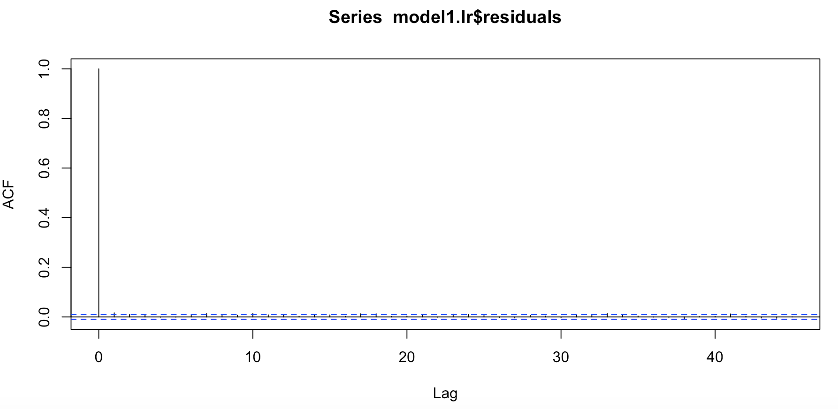

It is evident from this analysis that linear regression to predict the exact number of shares does not work with a high degree of accuracy. It will be more fruitful to work on classes rather than trying to predict exact numbers.

**4.2 Logistic Regression**

Next I performed a binomial logistic regression on the *classes2* variable, which is the binary classification variable.

> summary(PredONP.logit)

Call:

glm(formula = classes2 ~ average_token_length + avg_positive_polarity +

factor(data_channel_is_bus) + factor(data_channel_is_entertainment) +

global_subjectivity + factor(is_weekend) + kw_avg_avg + kw_avg_max +

kw_avg_min + LDA_02 + LDA_03 + LDA_04 + num_hrefs + num_imgs +

num_videos + self_reference_avg_sharess + title_sentiment_polarity +

title_subjectivity, family = binomial, data = TrainONP)

Deviance Residuals:

Min 1Q Median 3Q Max

-2.3258 -1.0509 -0.6618 1.0909 2.0412

Coefficients:

Estimate Std. Error z value Pr(>|z|)

(Intercept) 1.286594 0.213200 6.035 1.59e-09 ***

average_token_length -0.250468 0.043810 -5.717 1.08e-08 ***

avg_positive_polarity -0.926314 0.157781 -5.871 4.34e-09 ***

factor(data_channel_is_bus)1 -0.163933 0.041469 -3.953 7.71e-05 ***

factor(data_channel_is_entertainment)1 -0.779142 0.035168 -22.155 < 2e-16 ***

global_subjectivity 0.799267 0.151011 5.293 1.20e-07 ***

factor(is_weekend)1 0.814059 0.033249 24.483 < 2e-16 ***

kw_avg_avg 0.400066 0.016609 24.087 < 2e-16 ***

kw_avg_max -0.156352 0.016050 -9.742 < 2e-16 ***

kw_avg_min 0.071447 0.013023 5.486 4.11e-08 ***

LDA_02 -0.972450 0.060903 -15.967 < 2e-16 ***

LDA_03 -0.539889 0.057322 -9.419 < 2e-16 ***

LDA_04 0.039890 0.056310 0.708 0.478695

num_hrefs 0.012721 0.001583 8.035 9.36e-16 ***

num_imgs 0.007705 0.002153 3.579 0.000346 ***

num_videos 0.035740 0.008281 4.316 1.59e-05 ***

self_reference_avg_sharess 0.205558 0.011450 17.952 < 2e-16 ***

title_sentiment_polarity 0.307797 0.055531 5.543 2.98e-08 ***

title_subjectivity 0.017524 0.035420 0.495 0.620786

---

Signif. codes: 0 ‘***’ 0.001 ‘**’ 0.01 ‘*’ 0.05 ‘.’ 0.1 ‘ ’ 1

(Dispersion parameter for binomial family taken to be 1)

Null deviance: 54951 on 39643 degrees of freedom

Residual deviance: 50387 on 39625 degrees of freedom

AIC: 50425

Number of Fisher Scoring iterations: 4

Using the ROCR package, I calculated the area under the ROC curve and it is a decent 69.42%.

> print(paste("AUC =", round(performance(ROCRpred, "auc")@y.values[[1]], digits = 4)*100, "%"))

[1] "AUC = 69.42 %"

The accuracy for this model is also a decent 64.38%

> confusionM.logit = table(onp$classes2, predictONP.logit > 0.5)

> print(paste("Accuracy =", round(sum(diag(confusionM.logit))/sum(confusionM.logit),4)*100, "%"))

[1] "Accuracy = 64.38 %"

**4.3 CART Binary Classification Using Cross-Validation**

Following up logistic regression, I try a CART machine-learning model. I used *classes2* as the dependent variable for learning. I used cross-validation of get the ‘complexity parameter’ for the CART model. Training the model using cross-validation returns a complexity parameter of 0.01.

CART

39644 samples

18 predictor

2 classes: '0', '1'

No pre-processing

Resampling: Cross-Validated (10 fold, repeated 4 times)

Summary of sample sizes: 35680, 35678, 35680, 35680, 35679, 35680, ...

Resampling results across tuning parameters:

cp Accuracy Kappa

0.01 0.6169405 0.23274214

0.02 0.6153137 0.22934745

.

.

.

Accuracy was used to select the optimal model using the largest value.

The final value used for the model was cp = 0.01.

Next, I built the actual CART model using this parameter. The accuracy and AUC obtained from this model was lower than the logistic regression model.

> confusionM.cart = table(TestONP$classes2, predictONP.class)

> print(paste("Accuracy =", round(sum(diag(confusionM.cart))/sum(confusionM.cart),4)*100, "%"))

[1] "Accuracy = 61.94 %"

> print(paste("AUC =", round(performance(pred.class, "auc")@y.values[[1]], digits = 4)*100, "%"))

[1] "AUC = 62.53 %"

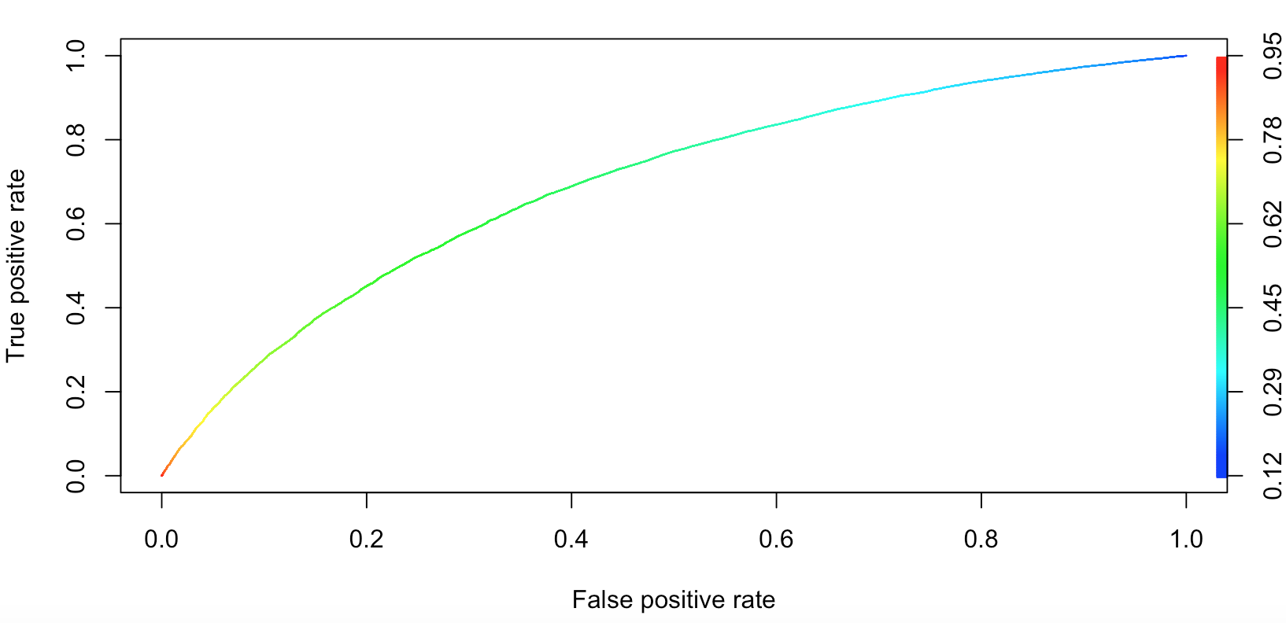

As we can see, accuracy is 61.94% and AUC is 62.53%.

**4.3 Random Forest Binary Classification**

Since CART model returned results less accurate than logistic regression, I tried the Random Forest machine-learning model for classification. Again, I used *classes2* variable as the dependent variable in this classification. I used 200 trees for this model with node size of 25. An error plot of the model shows that errors or both classes go down and stabilized around 200 trees mark. The results from this model were superior to all the previous models.

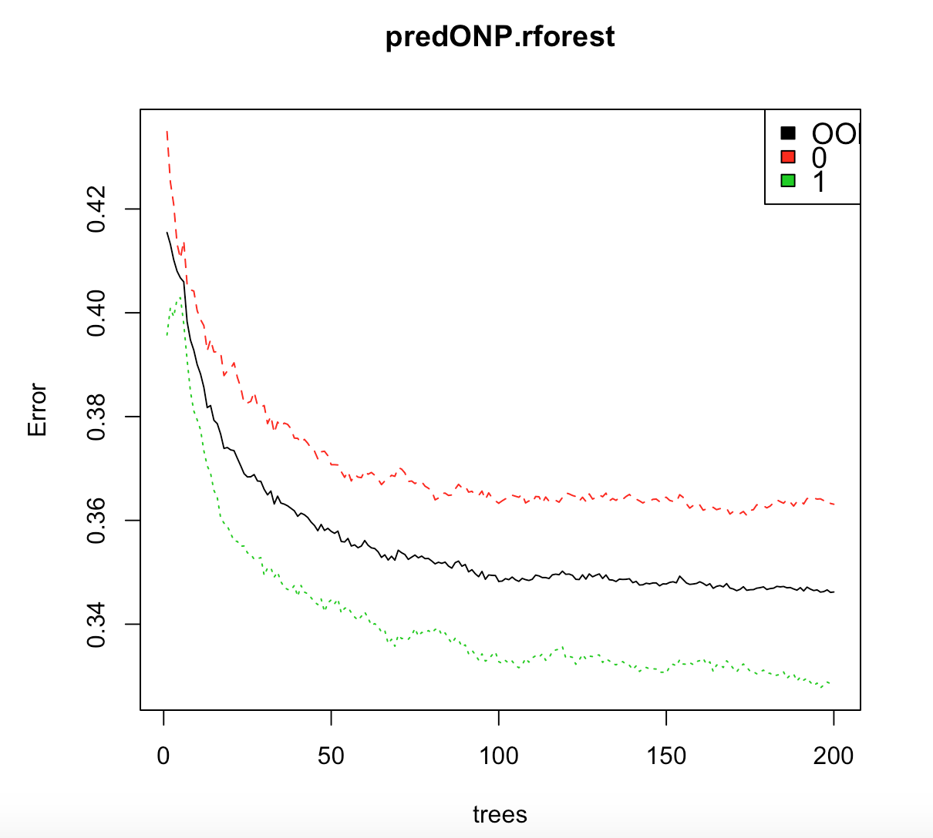

> confusionM.RF = table(TestONP$classes2, predictONP.forsest.2class)

> print(paste("Accuracy =", round(sum(diag(confusionM.RF))/sum(confusionM.RF),4)*100, "%"))

[1] "Accuracy = 83.75 %"

> print(paste("AUC =", round(performance(predrocr, "auc")@y.values[[1]], digits = 4)*100, "%"))

[1] "AUC = 92.19 %"

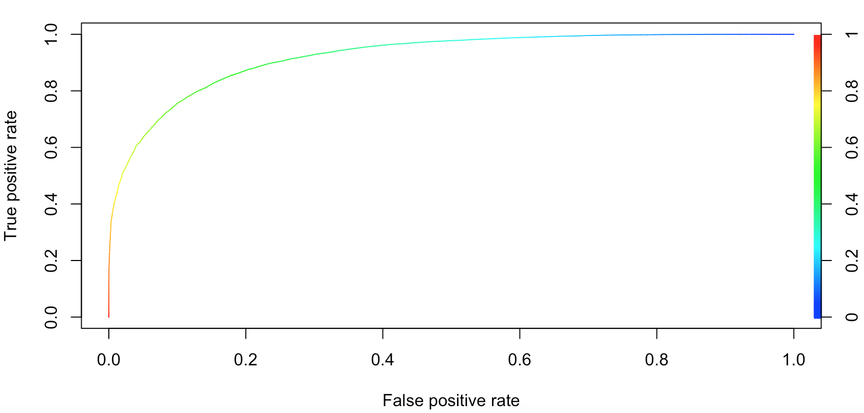

As we can see, accuracy for this model is 83.75% and AUC is 92.19%.

**4.4 Random Forest 4-class Classification**

Following the promising results from the previous Random Forest model, I tried to run this model on four classes instead of two. I used the *classes* variable as the dependent variable in this model, with 300 trees. As we can see below, error for class 3 increases with increasing number of trees while for other classes and the error actually decreaseses as the trees increase, along with the Out-of-Bag error.

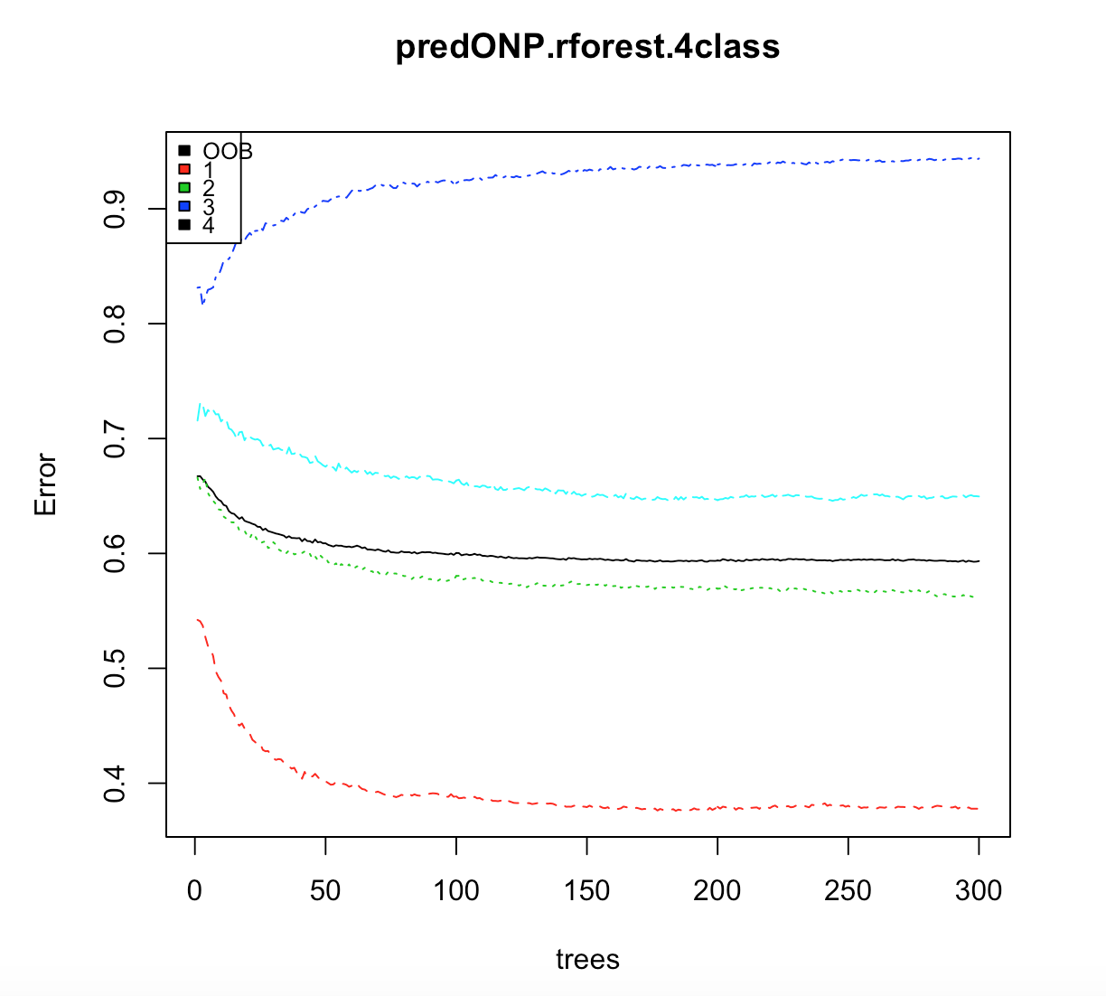

This Random forest model, as the previous one, makes predictions with high accuracy.

> print(paste("Accuracy =", round(sum(diag(confusion.matrix))/sum(confusion.matrix),4)*100, "%"))

[1] "Accuracy = 68.7 %"

Even with four classes, this model gives a decent accuracy of 68.7%, calculated using the Exact Match Ratio method.

**5. Conclusion**

My conclusion from this study is that among all the techniques I used for the analysis of this problem, Random Forest by far works the best on both 2-class and 4-class classification. Using a rigorous feature selection process with finely tuned parameters for Random Forest, I was able to achieve an accuracy of 83.75 %, higher than any other proposed solution currently available on the web. I was also able to achieve a decent accuracy of 68.7% on 4-class classification, which more realistically reflects the actual share categories of Mashable.com news articles.